Network Protocols & Communications (Part 2)

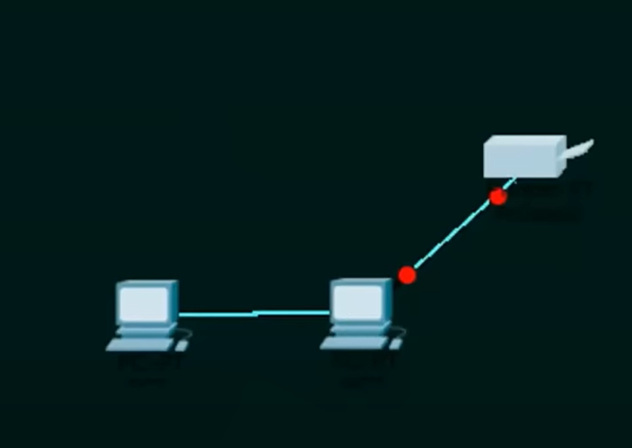

**Peer-to-peer network:**

1. No centralized administration
2. All peers are equal
3. Simple sharing applications
4. Not scalable.

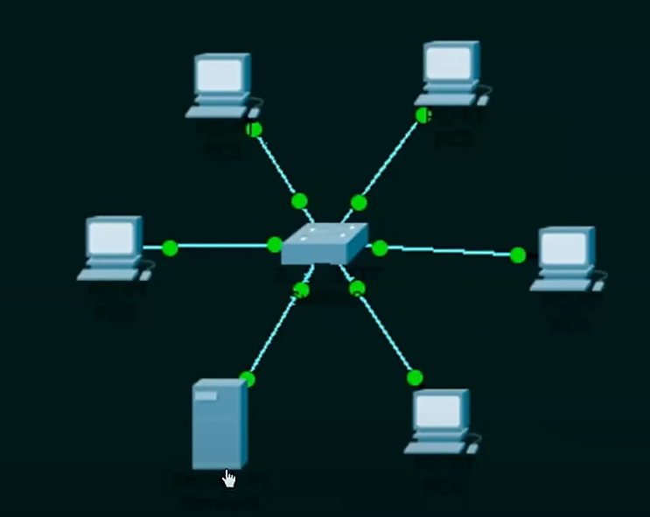

Client server Network:

1. Centralize administration
2. Also called Request-Response model
3. Scalable
4. Server may be overloaded.

(Too dependent on the server)